blanco 400/132kV substation & loop in – loop out lines
Wetland Assessment

SEF Reference No. 504769

Eskom Holdings SOC Limited
Megawatt Park
Maxwell Drive
Sandton
P.O. Box 1091
Johannesburg
2001

Prepared by:
Strategic Environmental Focus (Pty) Ltd
P.O. Box 74785
Lynnwood Ridge
0040
Tel. No.: (012) 349-1307
Fax. No.: (012) 349-1229
E-mail: sef@sefsa.co.za



December 2013
Compiled by | Authorised by
Willem Lubbe Cand. Sci. Nat.  Wetland Specialist  SACNASP Reg. No. 100064/08 | Byron Grant Pr. Sci. Nat.  Project Manager & Senior Natural Scientist  SACNASP Reg. No. 400275/08  _______________  Date: 10/12/2013

Declaration of Independence

I, Willem Lubbe, in my capacity as a specialist consultant, hereby declare that I -
- Act as an independent consultant;
- Do not have any financial interest in the undertaking of the activity, other than remuneration for the work performed in terms of the National Environmental Management Act, 1998 (Act 107 of 1998);
- Have and will not have vested interest in the proposed activity proceeding;
- Have no, and will not engage in, conflicting interests in the undertaking of the activity;
- Undertake to disclose, to the competent authority, any material information that has or may have the potential to influence the decision of the competent authority or the objectivity of any report, plan or document required in terms of the National Environmental Management Act, 1998 (Act 107 of 1998);
- Will provide the competent authority with access to all information at my disposal regarding the application, whether such information is favourable to the applicant or not;
- As a registered member of the South African Council for Natural Scientific Professions, will undertake my profession in accordance with the Code of Conduct of the Council, as well as any other societies to which I am a member;
- Based on information provided to me by the project proponent, and in addition to information obtained during the course of this study, have presented the results and conclusion within the associated document to the best of my professional judgement; and
- Undertake to have my work peer reviewed on a regular basis by a competent specialist in the field of study for which I am registered.

________________________  Willem Lubbe Cand. Sci. Nat.  Wetland specialist  SACNASP Reg. No. 100064/08 | 10 December 2013  Date

EXECUTIVE SUMMARY

Strategic Environmental Focus (Pty) Ltd, as independent environmental practitioners and ecological specialists, was appointed by Eskom Holdings SOC Limited Limited to undertake wetland assessments for the proposed establishment of a new 400/132kV MTS, with an expected development footprint of approximately 425m², and loop in – loop out line with a length estimated at 2.2km., near the town of Blanco in the Western Cape. Six alternative sites were investigated for the proposed new substation, along with the associated alternative loop in – loop out powerlines. The wetland assessment covered a 200m corridor surrounding each line alternative. The terms of reference for the current study were as follows:
- Delineate and classify wetland and riparian areas within the study area;
- Determine the Present Ecological State as well as the Ecological Importance and Sensitivity of the identified wetlands within the study area; and
- Identify possible impacts and mitigation measures of proposed activities associated with wetlands within the study area.

The four main wetland indicators used during the wetland delineation process included the terrain unit indicator, soil wetness indicator, and the presence or absence of hydric soils and hydrophytes. Three hydro-geomorphic types were delineated and classified into fourteen separate hydro-geomorphic units within the study area. These include valley-bottom wetlands without a channel, valley-bottom wetlands with a channel and hillslope seepage wetlands that is connected to a watercourse.

From a functional perspective, wetlands within the study area serve to improve habitat within and downstream of the study area through the provision of various ecosystem services such as streamflow regulation, flood attenuation, groundwater recharge, nitrogen removal, phosphate removal, toxicant removal, particle assimilation and provision of natural resources including habitat for a variety of taxa. Each wetland’s ability to contribute to ecosystem services within the study area is further dependant on the particular wetland’s Present Ecological State in relation to a benchmark or reference condition. Results of the Wet-health assessment indicated that the Present Ecological State for wetlands within the study area ranged from being moderately modified with some loss of natural habitat to being seriously modified with an extensive loss of natural habitat and associated functional attributes. An Ecological Importance and Sensitivity (EIS) assessment was undertaken to rank associated wetlands in terms of provision of goods and service or valuable ecosystem functions which benefit people, biodiversity support and ecological value, and reliance of subsistence users (especially basic human needs uses). The moderate to low Ecological Importance and Sensitivity assigned to most of the various wetlands was attributed primarily to the loss of functionality as a result of land use practices, especially cultivation as well as alien vegetation infestation.

Based on the current and proposed activities and taking into consideration the present state of the wetlands and their associated functionality and biodiversity, several potential impacts on wetlands were identified. As a result, several measures are recommended to be undertaken to limit impacts on the associated wetlands. In summary, alternative 6 was deemed the preferred site and powerline route option, with alternative site 3 and powerline route the second option from a wetland perspective. In addition to route and site options, several specific and general mitigation measures were also recommended that should be adhered to in order to reduce potential impacts on wetlands within the study area.

TABLE OF CONTENTS

1. INTRODUCTION 8
1.1 Project Description 8
1.2 Terms of Reference 8
1.3 Assumptions and Limitations 8
1.4 Methodology 9
2. BACKGROUND INFORMATION 9
2.1 Locality 9
2.2 Biophysical description 9
2.3 National Freshwater Ecosystem Priority Areas Status 13
3. RESULTS 15
3.1 Wetland soils 15
3.2 Wetland Vegetation 18
3.3 Delineated Wetland Areas 18
4. FUNCTIONALITY AND PRESENT ECOLOGICAL STATUS 22
4.1 Present Ecological State for HGM 1 25
4.2 Present Ecological State for HGM 2 25
4.3 Present Ecological State for HGM 3 25
4.4 Present Ecological State for HGM 4 26
4.5 Present Ecological State for HGM 5 26
4.6 Present Ecological State for HGM 6 26
4.7 Present Ecological State for HGM 7 27
4.8 Present Ecological State for HGM 8 27
4.9 Present Ecological State for HGM 9 27
4.10 Present Ecological State for HGM 10 28
4.11 Present Ecological State for HGM 11 28
4.12 Present Ecological State for HGM 12 28
4.13 Present Ecological State for HGM 13 29
5. ECOLOGICAL IMPORTANCE AND SENSITIVITY 29
6. IMPACT ASSESSMENT AND MITIGATION 33
6.1 Assessment Criteria 33
6.2 Impact Assessment 34
7. CONCLUSION 39
8. REFERENCES 43
APPENDIX A 46
Wetland delineation methodology 46
Determination of Ecological Importance and Sensitivity 47

LIST OF FIGURES
Figure 1: Locality map of the study area. 12
Figure 2: Geology associated with study area. 13
Figure 3: FEPA wetland areas within the study area. 19
Figure 4: Delineated wetland areas within the study area. 19
Figure 5: Wetland PES within the study area. 19

LIST OF PHOTOGRAPHS
Photograph 1: Clayey soils with signs of saturation found in the valley bottom system...................................................................................................................... 16
Photograph 2: Palmiet (Prionium serratum) dominated an unchannelled valley-bottom wetland system………………………………………………………………….. 17

LIST OF TABLES
Table 1: Wetland hydro-geomorphic types typically supporting inland wetlands in South Africa (adapted from Kotze et al, 2005) 16
Table 2: Potential wetland services and functions in study area 18
Table 3: Preliminary rating of the hydrological benefits likely to be provided by a wetland given its particular hydro-geomorphic type (Kotze et al., 2005) 19
Table 4: Wet-Health scores for HGM 1 19
Table 5: Wet-Health scores for HGM 2 20
Table 6: Wet-Health scores for HGM 3 20
Table 7: Wet-Health scores for HGM 4 21
Table 8: Ecological Importance and Sensitivity scores for wetland complexes 22
Table 9: Scale used to determine significance ranking 24
Table 10: Possible additional impacts arising during the operational phase 25
Table 11: Potential impacts during the Decommissioning Phase of the proposed project 25
Table 12: Interpretation of scores for determining present ecological status (Kleynhans 1999) 42
Table 13: Example of scoring sheet for Ecological Importance and sensitivity 42
Table 14: Category of score for the Ecological Importance and Sensitivity 43

INTRODUCTION
With South Africa being a contracting party to the Ramsar Convention on Wetlands, the South African government has taken a keen interest in the conservation, sustainable utilisation and rehabilitation of wetlands in South Africa. This aspect is also reflected in various pieces of legislation controlling development in and around wetlands and other water resources, of which the most prominent may be the National Water Act, Act 36 of 1998. As South Africa is an arid country, with a mean annual rainfall of only 450mm in relation to the world average of 860mm (DWAF, 2003), water resources and the protection thereof becomes critical to ensure their sustainable utilisation. Wetlands perform various important functions related to water quality, flood attenuation, stream flow augmentation, erosion control, biodiversity, harvesting of natural resources, and others, highlighting their importance as an irreplaceable habitat type. Determining the location and extend of existing wetlands, as well as evaluating the full scope of their ecosystem services, form an essential part in striving towards sustainable development and protection of water resources.

Project Description
Strategic Environmental Focus (Pty) Ltd, as independent environmental practitioners and ecological specialists, was appointed by Eskom Holdings SOC Limited to undertake wetland assessments for the proposed establishment of a new 400/132kV MTS, with an expected development footprint of approximately 425m², and loop in – loop out line with a length estimated at 2.2 km, near the town of Blanco in the Western Cape. Six alternative sites are being considered for the proposed substation, along with the associated alternative loop in – loop out powerlines. The ecological assessment covered a 200m corridor surrounding each line alternative, 100m on either side of the centre line, which will make provision for any ‘shifting’ of pole positions at the final stages of the project.

Terms of Reference
The terms of reference for the current study were as follows:
- Delineate and classify wetland and riparian areas within the study area;
- Determine the Present Ecological State as well as the Ecological Importance and Sensitivity of the identified wetlands within the study area; and
- Identify possible impacts and mitigation measures of proposed activities associated with wetlands within the study area.

Assumptions and Limitations
In order to obtain definitive data regarding the biodiversity, hydrology and functioning of particular wetlands, studies should ideally be conducted over a number of seasons and over a number of years. The current study relied on information gained during a two day field survey conducted during a single season, desktop information for the area, information obtained from provincial conservation authorities, as well as professional judgement and experience. Delineations of wetlands were dependent on the extrapolation of data obtained during field surveys and from interpretation of orthophotos and other imagery. The potential for errors in delineating boundaries therefore exists as it would be impractical and expensive to verify each wetland boundary in totality. Further, the dominance of the geology and associated effect on soil properties combined with historic land use practices throughout large sections of the study area made delineations of seepage areas difficult. The presence of hydromorphic podzols and high organic content soils close to a geological boundary on the most northern section of the study area also increased the difficulty of seepage delineations in this area. In addition, soil form classification was made by a wetland ecologist and not a specialised soil scientist which could potentially result in different interpretations of diagnostic horizons in some instances. Only wetlands within or within the vicinity of the proposed development lay out were assessed for their functionality and Present Ecological Status.

Methodology
Field surveys were undertaken from the 11th to the 15th of March as well as the 26th to the 28th of November 2013. The wetland delineation was based on the legislatively required methodology as described by DWAF (2005). In order to gauge the Present Ecological Status (PES) of wetlands within the study area, a Level 2 Wet-Health assessment (Macfarlane et al., 2008) was applied in order to assign PES categories to identified wetlands. For a more comprehensive study approach and specific methodologies employed during the current study, see Appendix A.

2. BACKGROUND INFORMATION

2.1 Locality
The study area is located within Eden District Municipality in the Western Cape, approximately 5 km due west of the town of Blanco and falls under the jurisdiction of the George Local Municipality. The study area lies within Quarter Degree Grid Cell (QDGC) 3322CD between 33°56’06” – 33°58’00” south and 22°19’15” – 22°21’05” east (Figure 1).

Biophysical description
Climate
The region usually receives around 670mm of rain per year, with rainfall occurring evenly throughout the year. The region receives the lowest rainfall in June and the highest in March. The average midday temperature ranges from 18°C in July to 27.8°C for January-February. The region is the coldest in July when the temperature drops to 6.2°C on average during the night. Frost incidence is 2 to 3 days per year (Mucina & Rutherford, 2006).
Geology
The region is dominated by George batholith of the Cape Granite suite (Mucina & Rutherford, 2006). The majority of the study site is dominated by granite, with some quartzite in the northern section of the study site (Figure 2).
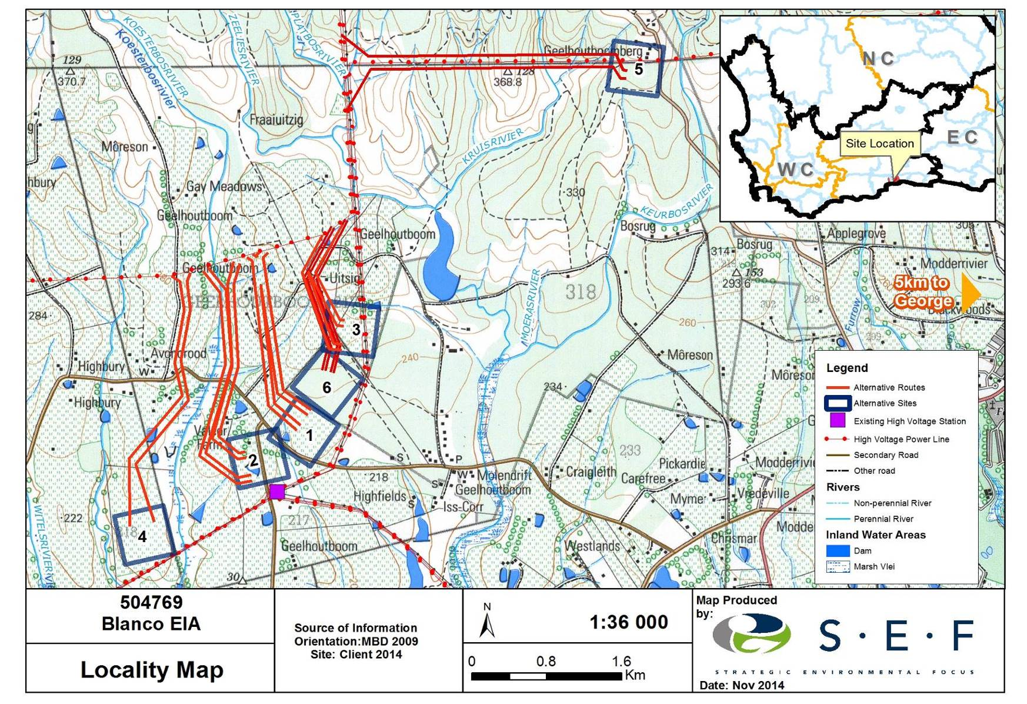
Figure 1: Locality map of the study area
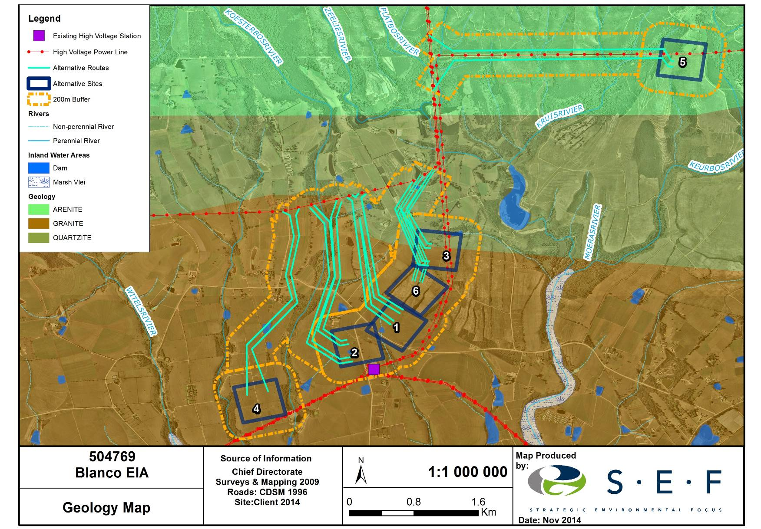
Figure 2: Geology map of the study area.
Regional Vegetation and Wetland Ecosystem Type
The study site is located within the Fynbos biome which occupies most of the Cape Fold Belt as well as the adjacent lowlands between the mountains and the Atlantic Ocean. There are three major vegetation complexes within the Fynbos biome namely Fynbos, Renosterveld and Strandveld. Directly translated Fynbos means “fine bush” and comprises an evergreen, fire-prone shrubland characterised by restioid bushes and ericoid shrubs (including families such as Ericaceae, Asteraceae, Rhamnaceae, Thymelaeaceae and Rutaceae) (Mucina & Rutherford, 2006). In structural terms, Fynbos is defined as a shrubland or restioland with a cover of more than 5% Restionaceae which usually contains elements of Ericaceae and Proteaceae. The Fynbos biome is divided into smaller units known as vegetation types. According to Mucina & Rutherford (2006), the study area is situated within the Garden Route Granite Fynbos and Garden Route Shale Fynbos (Figure 2).

The Garden Route Granite Fynbos is limited to the Western Cape Province where it consists of moderately undulating plains and undulating hills on the coastal forelands. Important taxa in the Garden Route Granite Fynbos include tall shrubs such as Passerina corymbosa, Cliffortia serpyllifolia, Protea coronata, P.lanceolata, P.nerriifolia as well as low shrubs such as Erica discolour, E.peltata, Phylica confusa, Syncarpha paniculata, Agathosma ovata, and Hermannia angularis. Succulent shrubs include Lampranthus sociorum and graminoids such as Tetraria cuspidata, Brachiaria serrata, Eragrostis capensis, Ficinia nigrescens, Heteropogon contortus, Pentaschistis eriostoma, Restio triticeus and Themeda triandra. According to Mucina & Rutherford (2006), this vegetation type is classified as Endangered, with less than 1% conserved in the proposed Garden Route National Park while more than 70% has been transformed by cultivation, pine plantations and urban development.

The Garden Route Shale Fynbos occurs in the Western and Eastern Cape Provinces and includes undulating hills and moderately undulating plains on the coastal forelands. In the wetter areas this vegetation type includes tall, dense proteoid and ericaceous Fynbos while the drier areas are dominated by graminoid Fynbos (Mucina & Rutherford, 2006). Important taxa in the Garden Route Shale Fynbos include Leucadendron eucalyptifolium, Protea aurea subsp. aurea, P.coronata, Leucospermum formosum, Metalasia densa and Passerina corymbosa while the low shrubs include species such as Acmadenia alternifolia, A.tetragona, Anthospermum aethiopicum, Cliffortia ruscifolia, Leucadendron salignum, Pelargonium cordifolium and Eriospermum vermiforme. Graminoid species include Ischyrolepis sieberi, Aristida junciformis, Brachiaria serrata, Cymbopogon marginatus, Elegia juncea, Eragrostis capensis, Restio triticeus, Themeda triandra and Tristachya leucothrix.

According to Mucina & Rutherford (2006), Garden Route Shale Fynbos is classified as Least Threatened with only about 1% transformed and infestations of alien species generally being low.

Further, according to According to the National Biodiversity Assessment’s Freshwater Component Eastern Fynbos-Rhenosterveld Sandstone Fynbos, Eastern Fynbos-Rhenosterveld Shale Fynbos, Eastern Fynbos-Rhenosterveld Granite Fynbos (Nel et al., 2011). Both Eastern Fynbos-Rhenosterveld Shale Fynbos as well as Eastern Fynbos-Rhenosterveld Granite Fynbos are regarded as Critically Endangered according to their Ecosystem Threat Status (Nel et al., 2011).

National Freshwater Ecosystem Priority Areas Status
The National Freshwater Ecosystem Priority Areas project is a project currently underway, and represents a multi-partner project between the Council for Scientific and Industrial Research (CSIR), South African National Biodiversity Institute (SANBI), Water Research Commission (WRC), Department of Water Affairs (DWA), Department of Environmental Affairs (DEA), Worldwide Fund for Nature (WWF), South African Institute of Aquatic Biodiversity (SAIAB) and South African National Parks (SANParks). More specifically, the NFEPA project aims to:
- Identify Freshwater Ecosystem Priority Areas (hereafter referred to as ‘FEPAs’) to meet national biodiversity goals for freshwater ecosystems; and
- Develop a basis for enabling effective implementation of measures to protect FEPAs, including free-flowing rivers.
The project further aims to maximize synergies and alignment with other national level initiatives such as the National Biodiversity Assessment (NBA) and the Cross-Sector Policy Objectives for Inland Water Conservation. Based on current outputs of the NFEPA project, no NFEPA wetland areas or wetland clusters were identified within the study area, Figure 3.

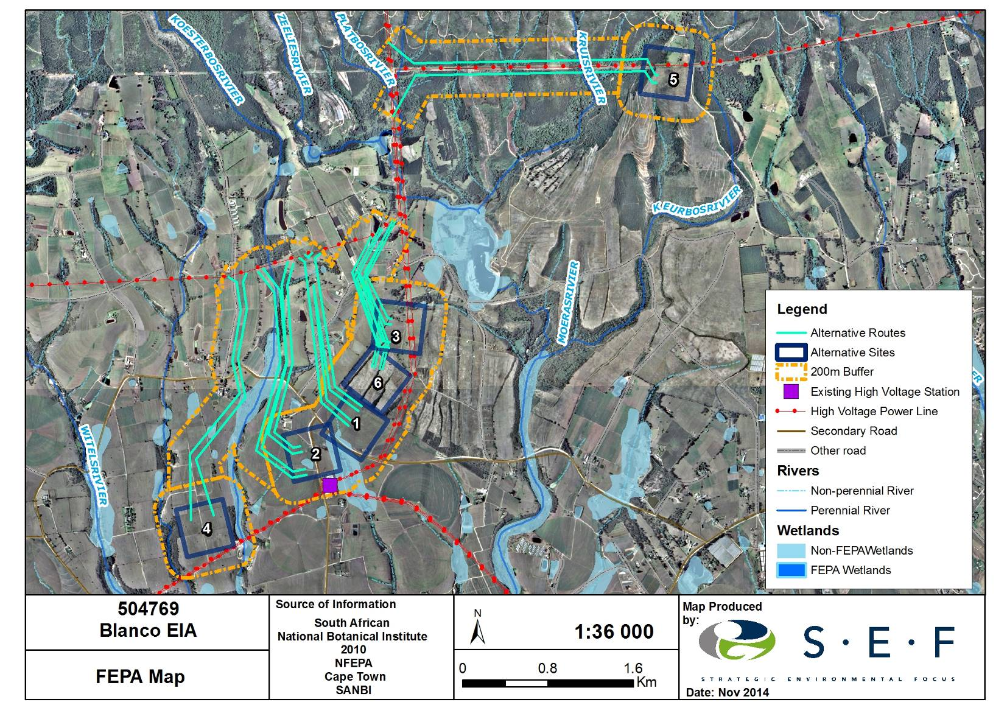
Figure 3: FEPA map of the study area

3. RESULTS

Wetland soils
According to DWAF (2005), the permanent zone of a wetland will always have either Champagne, Katspruit, Willowbrook or Rensburg soil forms present, as defined by the Soil Classification Working Group (1991). The seasonal and temporary zones of the wetlands will have one or more of the following soil forms present (signs of wetness incorporated at the form level): Kroonstad, Longlands, Wasbank, Lamotte, Estcourt, Klapmuts, Vilafontes, Kinkelbos, Cartref, Fernwood, Westleigh, Dresden, Avalon, Glencoe, Pinedene, Bainsvlei, Bloemdal, Witfontein, Sepane, Tukulu, Montagu. Alternatively, the seasonal and temporary zones will have one or more of the following soil forms present (signs of wetness incorporated at the family level): Inhoek, Tsitsikamma, Houwhoek, Molopo, Kimberley, Jonkersberg, Groenkop, Etosha, Addo, Brandvlei, Glenrosa, Dundee (DWAF, 2005).

Hydric soil present within the study area included Champagne, Longlands, Katspruit, Westleigh, Tukulu, Dresden, Fernwood and Pinedene. The more clayey and organic rich Katspruit and champagne soil forms were characteristic of the valley-bottom wetlands (Photograph 1) while the more sandy Pinedene, Longlands and Westleigh soil forms were associated with the hillslope seepage wetlands. Valley-bottom wetlands dominated by Palmiet (Prionium serratum) contained the Champagne soil form consisting of organic rich horizons, (Photograph 2). The Champagne soil form was also identified on the northern reaches of the study area at higher elevations dominating mid slopes of the Outeniqua mountains.

For an area to be considered a wetland, redoximorphic features must be present within the upper 500mm of the soil profile (Collins, 2005). Redoximorphic features are the result of the reduction, translocation and oxidation (precipitation) of iron and manganese oxides that occur when soils are saturated for sufficiently long periods of time to become anaerobic. Only once soils within 500mm of the surface display these redoximorphic features can the soils be considered to be hydric (wetland) soils. Redoximorphic features typically occur in three types (Collins, 2005):
- A reduced matrix - i.e. an in situ low chroma (soil colour), resulting from the absence of Fe³+ ions which are characterised by "grey" colours of the soil matrix (Photograph 1).
- Redox depletions - the "grey" (low chroma) bodies within the soil where Fe- Mn oxides have been stripped out, or where both Fe-Mn oxides and clay have been stripped. Iron depletions and clay depletions can occur.
- Redox concentrations - Accumulation of iron and manganese oxides (also called mottles). These can occur as:
  - Concretions - harder, regular shaped bodies;
  - Mottles - soft bodies of varying size, mostly within the matrix, with variable shape appearing as blotches or spots of high chroma colours; and,
  - Pore linings – zones of accumulation that may be either coatings on a pore surface, or impregnations of the matrix adjacent to the pore. They are recognized as high chroma colours that follow the route of plant roots, and are also referred to as oxidised rhizospheres.

According to the DWAF (2005), soil wetness indicators (i.e. identification of redoximorphic features) are the most important indicator of wetland occurrence due to the fact that soil wetness indicators (redoximorphic features) remain in wetland soils, even if they are degraded or desiccated. All augured soil samples within delineated wetland areas represented sufficient redoximorphic reactions to be classified as hydric soils, with brown and orange mottles as well as rhizospheres particularly evident.

Large sections within the study area (southern section) were previously disturbed and/or are currently under several different agricultural land uses, and represented soil forms resembling the Westleigh soil form (a hydric soil type). However, these Westleigh-resembling soil forms dominated in all terrain unit positions including the crest, scarp, midslope, footslope and valley-bottom positions which are a likely indicator that the dominance of the geology (George batholith of the Cape Granite suite) are responsible for the pedogenesis and not the geo-hydrological processes associated with the area. These areas were therefore not classified as wetland areas. However, the northern section of the study area were dominated by Arenite and contained large continuous hillslope seeps with Champagne soil forms and were recognised as hydric soils. Likely acidic conditions in the northern section would also conceal typical redoximorphic indicators although the presence of high organic content was used as hydromorphic indicator.

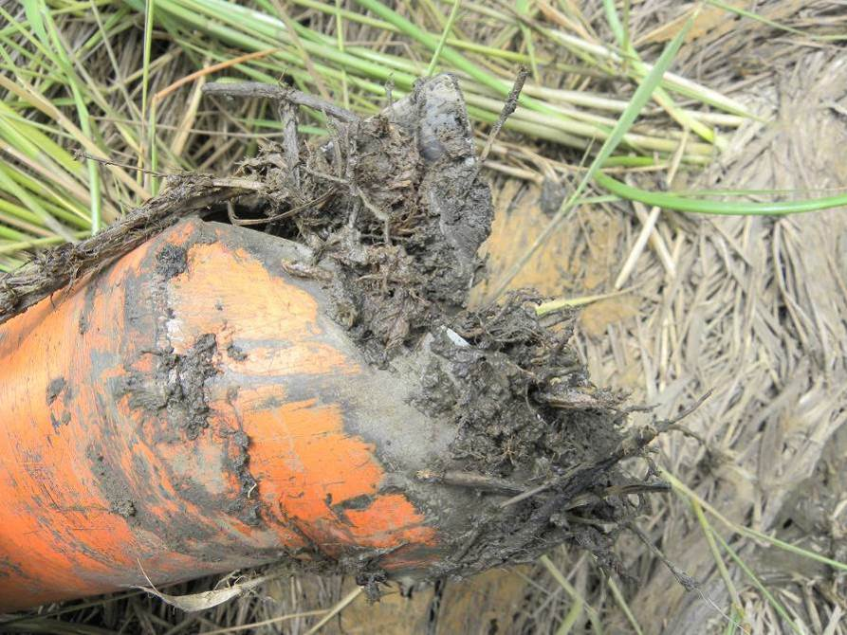
Photograph 1: Clayey soils, Katspruit soil form, with signs of permanent saturation found in a valley-bottom system

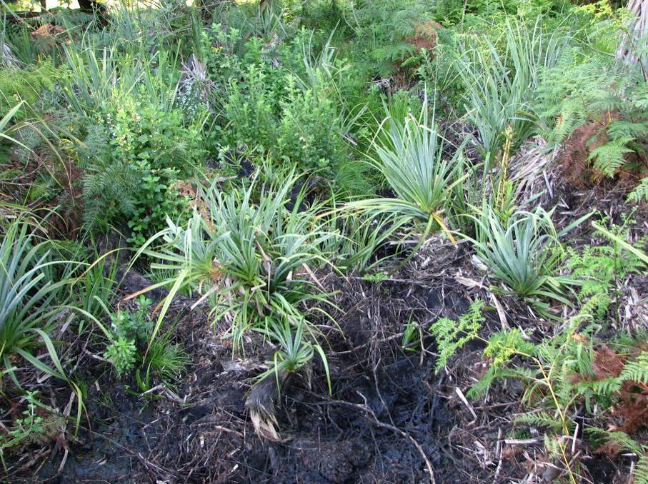
Photograph 2: Palmiet (Prionium serratum) dominated an unchannelled valley-bottom wetland system

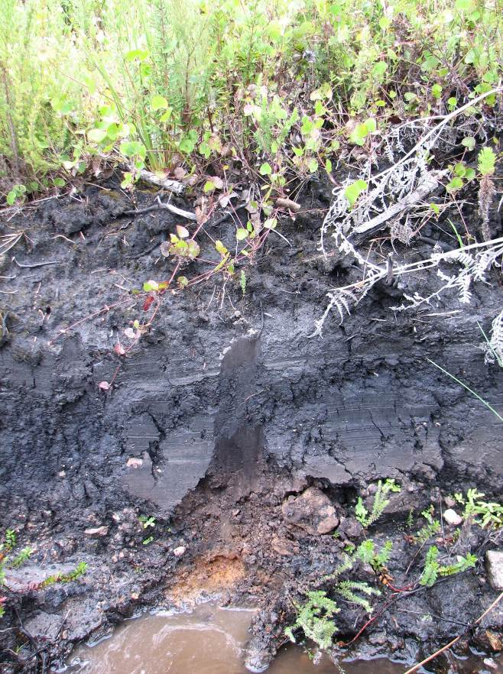
Photograph 3: Organic rich Champagne soil form on midslopes in northern section of study area

Wetland Vegetation
According to DWAF (2005), vegetation is regarded as a key component to be used in the delineation procedure for wetlands. Vegetation also forms a central part of the wetland definition in the National Water Act, Act 36 of 1998. Using vegetation as a primary wetland indicator however, requires undisturbed conditions (DWAF, 2005). A cautionary approach must be taken as vegetation alone cannot be used to delineate a wetland, as several species, while common in wetlands, can occur extensively outside of wetlands. When examining plants within a wetland, a distinction between hydrophilic (vegetation adapted to life in saturated conditions) and upland species must be kept in mind. There is typically a well-defined 'wetness' gradient that occurs from the centre of a wetland to its edge that is characterized by a change in species composition between hydrophilic plants that dominate within the wetland to upland species that dominate on the edges of, and outside of the wetland (DWAF, 2003). It is important to identify the vegetative indicators which determine the three wetness zones (temporary, seasonal and permanent) which characterize wetlands. Each zone is characterized by different plant species which are uniquely suited to the soil wetness within that zone.

In general, the study area has undergone a high level of transformation and is currently intensively utilised for agriculture with very little natural vegetation remaining. Areas within valley-bottom wetlands with permanent and seasonal zonation and associated high water tables contained hydrophylic plants such as Prionium serratum, Typha capensis, Phragmites sp., Juncus sp., Pteridium aquilinum, Cyperus sp., Pycereus macranthus cf., P. polystachyos, Schoenoplectus brachyceras, Fimbristylis sp. and Isolepis sp. Several Restionaceae containing elements of Ericaceae and Proteaceae were associated with the Champagne soil forms in the northern section of the study area

The temporary wetland areas consisted of a mixture of facultative wetland and terrestrial species such as Asparagus burchellii, Searsia glauca, Rapanea melanophloeos, Burchellia bubaline, Thermeda triandra, Eragrostis plana, Eragrostis gummiflua, Aristida sp., Andropogan sp., Setaria sphacelata, Hyparrenhia sp., Monopsis decipiens and Nidorella anomala.

Alien vegetation species were numerous and dominated several drainage lines, including species such as Acacia mearnsii, Solanum mauritianum, Eucalyptus spp., Pinus spp., Acacia melanoxylon, Crotaderia selloana, Bidens pilosa and Tagetes minuta.

Delineated Wetland Areas
According to the National Water Act (Act no 36 of 1998) a wetland is defined as, “land which is transitional between terrestrial and aquatic systems where the water table is usually at or near the surface, or the land is periodically covered with shallow water, and which land in normal circumstances supports or would support vegetation typically adapted to life in saturated soil.” Wetlands typically occur on the interface between aquatic and terrestrial habitats and therefore display a gradient of wetness – from permanent, to seasonal, to temporary zones of wetness - which is represented in their plant species composition, as well as their soil characteristics. It is important to take cognisance of the fact that not all wetlands have visible surface water. An area which has a high water table just below the surface of the soil is as much a wetland as a pan that only contains water for a few weeks during the year.

Hydrophytes and hydric soils are subsequently used as the two main wetland indicators. The presence of these two indicators is indicative of an area that has sufficient saturation to classify the area as a wetland. The soil form indicator examines soil forms as defined by the Soil Classification Working Group. Typically soil forms associated with prolonged and frequent saturation by water, where present, is a sign of wetland occurrence (DWAF, 2005). The Soil Classification Working Group has identified various soil types that typically occur within the different zones found within a wetland, i.e. a permanent, seasonal and temporary zone. Terrain unit refers to the land unit in which the wetland is found. Wetlands can occur across all terrain units from the crest to valley bottom. Many wetlands occur within valley bottoms, but wetlands are not exclusively found within depressions. Terrain unit is a useful indicator in assessing the hydro-geomorphic form of the wetland.

In practice all four indicators should be used in any wetland assessment / delineation exercise, the presence of redoximorphic features being most important, with the other indicators being confirmatory. An understanding of the hydrological processes active within the area is also considered important when undertaking a wetland assessment. Indicators should be 'combined' to determine whether an area is a wetland and to delineate the boundary of a wetland. According to the DWAF delineation guidelines, the more wetland indicators that are present, the higher the confidence of the delineation. In assessing whether an area is a wetland, the boundary of a wetland or a non- wetland area should be considered to be the point where indicators are no longer present.

Three HGM types were delineated within the study area and classified into fourteen separate hydro-geomorphic (HGM) units within or within the proximity of the study area. These included valley-bottom wetlands without a channel, valley-bottom wetlands with a channel and hillslope seepage wetlands that were connected to watercourses. The fourteen HGM units identified during the current assessment are presented graphically in Figure 3.

HGM units encompass three key elements (Kotze et al, 2005):
- Geomorphic setting. This refers to the landform, its position in the landscape and how it evolved (e.g. through the deposition of river borne sediment);
- Water source. There are usually several sources, although their relative contributions will vary amongst wetlands, including precipitation, groundwater flow, stream flow, etc.; and
- Hydrodynamics, which refers to how water moves through the wetland.

Table 1 describes the characteristics that form the basis for the classification of the HGM units in the study area.
Table 1: Wetland hydro-geomorphic types typically supporting inland wetlands in South Africa (adapted from Kotze et al, 2005)
Hydro-geomorphic types | Description | Source of water maintaining the wetland¹
Hydro-geomorphic types | Description | Surface | Sub-surface
Valley bottom with a channel | Valley bottom areas with a well defined stream channel but lacking characteristic floodplain features. May be gently sloped and characterized by the net accumulation of alluvial deposits or may have steeper slopes and be characterized by the net loss of sediment. Water inputs from main channel (when channel banks overspill) and from adjacent slopes. | *** | */ ***
Valley bottom without a channel | Valley bottom areas with no clearly defined stream channel, usually gently sloped and characterized by alluvial sediment deposition, generally leading to a net accumulation of sediment. Water inputs mainly from channel entering the wetland and also from adjacent slopes. | *** | */ ***
Hillslope seepage feeding a watercourse | Slopes on hillsides, which are characterized by the colluvial (transported by gravity) movement of materials. Water inputs are mainly from sub-surface flow and outflow is usually via a well defined stream channel connecting the area directly to a watercourse. | * | ***

¹ Precipitation is an important water source and evapotranspiration an important output in all of the above settings
Water source: * Contribution usually small
*** Contribution usually large
*/ *** Contribution may be small or important depending on the local circumstances

Wetland

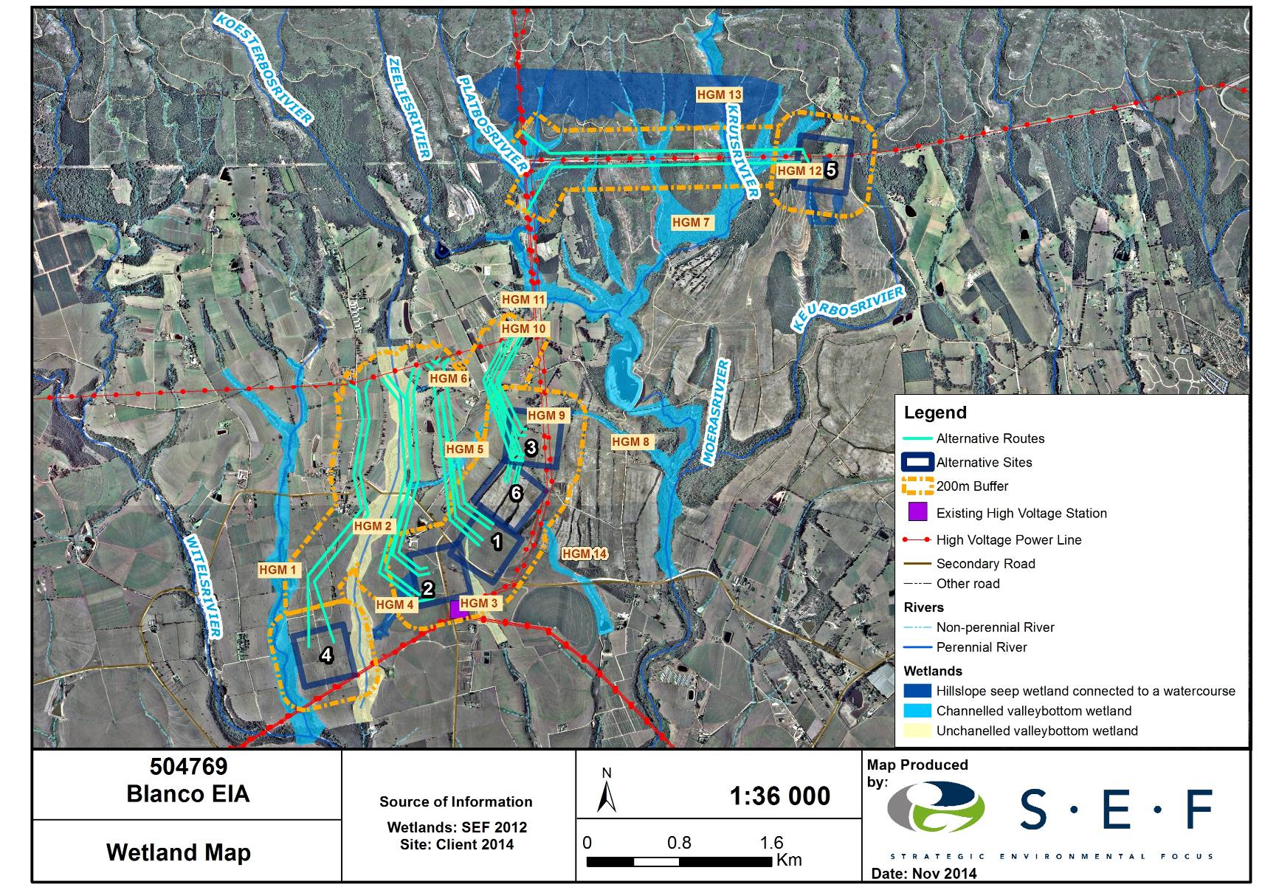

Figure 4: Delineated wetland areas within the study area.

FUNCTIONALITY AND PRESENT ECOLOGICAL STATUS

Wetlands within the study area serve to improve habitat within and potentially downstream of the study area through the provision of various ecosystem services. Many of these functional benefits therefore contribute directly or indirectly to increase biodiversity within the study area as well as downstream of the study area through provision and maintenance of appropriate habitat and associated ecological processes (Table 2).

Table 2: Potential wetland services and functions in study area
Function | Aspect
Water balance | Stream flow regulation
Water balance | Flood attenuation
Water balance | Groundwater recharge
Water purification | Nitrogen removal
Water purification | Phosphate removal
Water purification | Toxicant removal
Water purification | Water quality
Sediment trapping | Particle assimilation
Harvesting of natural resources | Reeds, Hunting, etc.
Livestock usage | Water for livestock
Livestock usage | Grazing for livestock
Crop farming | Irrigation

Hydro-geomorphic units are inherently associated with hydrological characteristics related to their form, structure and particularly their position in the landscape. This, together with the biotic and abiotic character (or biophysical environment) of wetlands in the study area, means that these wetlands are able to contribute better to some ecosystem services than to others (Kotze et al. 2005) (Table 3).

Each wetland’s ability to contribute to ecosystem services within the study area is further dependant on the particular wetland’s Present Ecological State (PES) in relation to a benchmark or reference condition. Present Ecological State scores were assigned for various wetlands within the study area using Wet-Health Level 2 assessment. Through the use of a scoring system, the perceived departure of elements of each particular system from the “natural-state” was determined. The following elements were considered in the assessment:
- Hydrologic: Flow modification (has the flow, rates, volume of run-off or the periodicity changed);
- Geomorphic (Canalisation, impounding, topographic alteration and modification of key drivers); and
- Biota (Changes in species composition and richness, Invasive plant encroachment, over utilization of biota and land-use modification).

Table 3: Preliminary rating of the hydrological benefits likely to be provided by a wetland given its particular hydro-geomorphic type (Kotze et al., 2005)
WETLAND HYDRO-GEOMORPHIC TYPE | HYDROLOGICAL BENEFITS POTENTIALLY PROVIDED BY THE WETLAND
WETLAND HYDRO-GEOMORPHIC TYPE | Flood attenuation |  | Stream flow regulation | Erosion control | Enhancement of water quality
 |  |  |  |  | Sediment trapping | Phos-phates | Nitrates | Toxicants²
WETLAND HYDRO-GEOMORPHIC TYPE | Early wet season | Late wet season
2. Valley bottom - channelled | + | ₀ | ₀ | ++ | + | + | + | +
3. Valley bottom -unchannelled | + | + | +? | ++ | ++ | + | + | ++
4. Hillslope seepage feeding a stream channel | + | ₀ | + | ++ | ₀ | ₀ | ++ | ++

²Toxicants are taken to include heavy metals and biocides
Rating: ₀ Benefit unlikely to be provided to any significant extent
+ Benefit likely to be present at least to some degree
++ Benefit very likely to be present (and often supplied to a high level)

The scores obtained in the PES assessment places the specific wetland unit in one of six categories (Table 4) and results displayed (Figure 4).

Table 4: Interpretation of scores for determining present ecological status (Kleynhans 1999)
Rating of Present Ecological State Category (PES Category)
CATEGORY A
Score: 0-0.9; Unmodified, or approximates natural condition.
CATEGORY B
Score: 1-1.9; Largely natural with few modifications, but with some loss of natural habitats.
CATEGORY C
Score: 2 – 3.9; Moderately modified, but with some loss of natural habitats.
CATEGORY D
Score: 4 – 5.9; Largely modified. A large loss of natural habitats and basic ecosystem functions has occurred.
OUTSIDE GENERAL ACCEPTABLE RANGE
CATEGORY E
Score: 6 -7.9; Seriously modified. The losses of natural habitats and basic ecosystem functions are extensive.
CATEGORY F
Score: 8 - 10; Critically modified. Modifications have reached a critical level and the system has been modified completely with an almost complete loss of natural habitat.

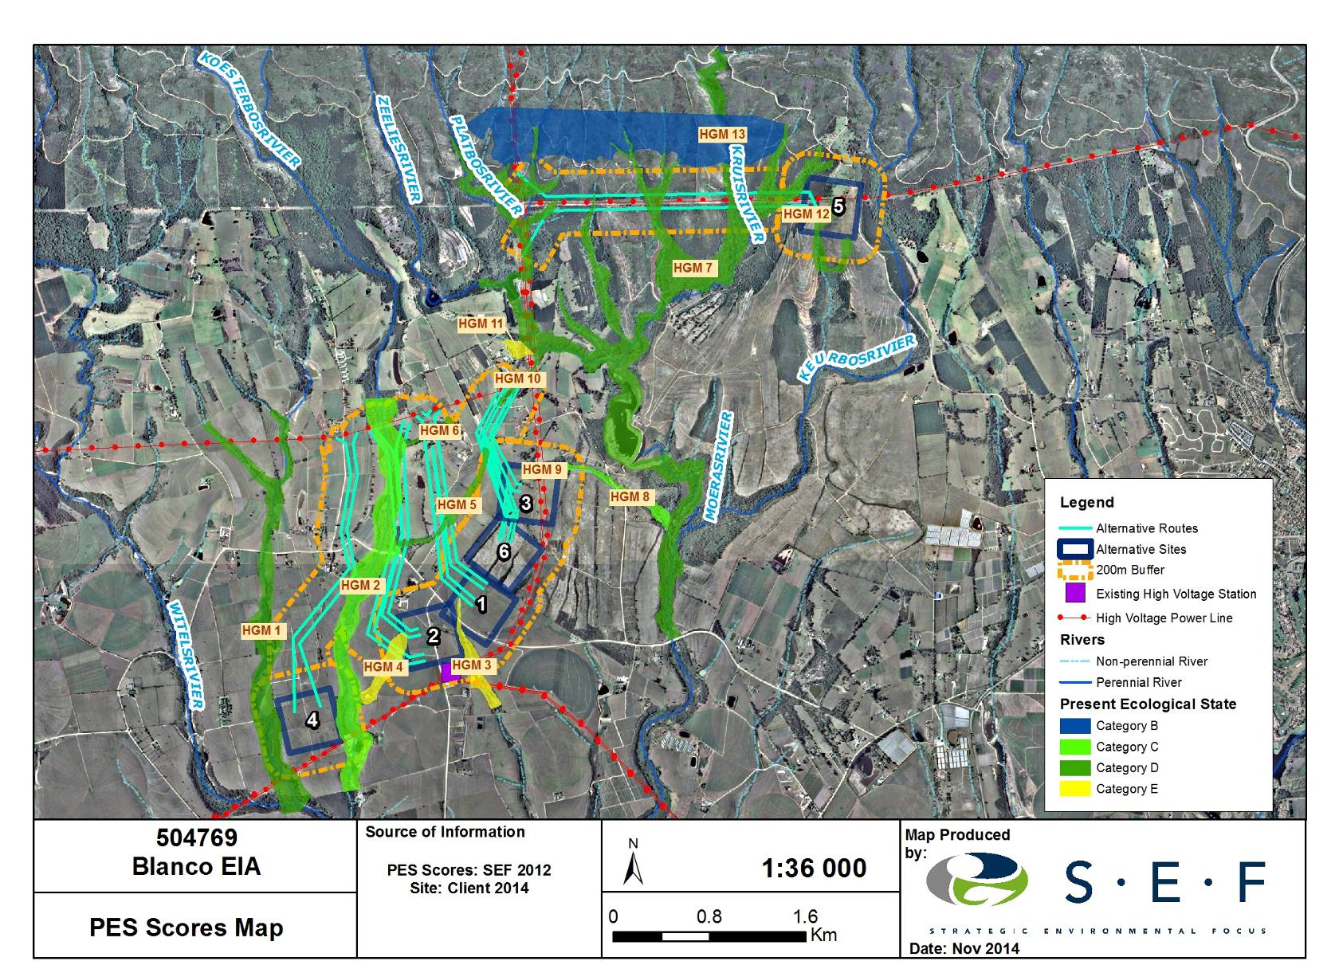

Figure 5: Wetland PES within the study area.

Present Ecological State for HGM 1
Wet-Health results obtained for HGM 1 are displayed in Table 5.
Table 5: Wet-Health scores for HGM 1
Hydrology | Geomorphology | Vegetation | PES category
4.3 | 4.4 | 6.3 | (D) 4.9

HGM 1 has been largely modified as a result of land use changes in its catchment. Changes to the hydrological and geomorphologic characteristics of this wetland could largely be attributed to several dirt roads which cross the wetland, the cultivation of crops infringing on the boundary of the temporary zone of the wetland and the formation of erosion gullies. Channel straightening has taken place in one section as a direct result of stormwater road run-off. The surface roughness of the channelled valley bottom wetland was considered to be moderate, offering resistance to the flow of surface water and aiding in the erosion control functions of the wetland. Alien infestation by vegetation species such as Acacia mearnsii and Populus spp. was considered to be high within this wetland unit.

Present Ecological State for HGM 2
Wet-Health results obtained for HGM 2 are displayed in Table 6.
Table 6: Wet-Health scores for HGM 2
Hydrology | Geomorphology | Vegetation | PES category
2 | 2.3 | 4.3 | C (2.7)

HGM 2 was delineated as an unchannelled valley-bottom wetland with a relatively large catchment. The hydrology and geomorphology of this particular wetland was perceived to be largely intact with only a couple of farm dams constructed within its course. The largest impact within this system was the invasion of alien vegetation, especially Acacia mearnsii. There are however large sections within the wetland which are dominated by indigenous species such as Prionium serratum (Palmiet), which plays an important role in binding riverbanks, dramatically increases surface roughness and are an important contributor to the organic rich soils. The organic rich Champagne soil form (likely consisting of peat) dramatically increases the wetlands water absorption and water holding capacity.

Present Ecological State for HGM 3
Wet-Health results obtained for HGM 3 are displayed in Table 7.
Table 7: Wet-Health scores for HGM 3
Hydrology | Geomorphology | Vegetation | PES category
7.3 | 6.9 | 7.8 | E (7.3)

HGM 3 was considered to be highly modified from a hydrological and geomorphological perspective through intensive agriculture practices. The valley-bottom wetlands catchment has been completely cultivated, including large pivot irrigation schemes and several farm dams that was placed in succession next to each other. Very little natural vegetation remains in the catchment and the wetland was dominated by annual crops with associated low basal cover.

Present Ecological State for HGM 4
Wet-Health results obtained for HGM 4 are displayed in Table 8.
Table 8: Wet-Health scores for HGM 4
Hydrology | Geomorphology | Vegetation | PES category
7.6 | 7.1 | 7.9 | E (7.5)

HGM 4, a hillslope seepage wetland connected to a watercourse, contained no natural vegetation as it was completely under pivot irrigation and cultivation practices. A single farm dam marked the boundary where the seepage connects to a watercourse. Due to the loss of natural habitat and ecosystem services within HGM 4, the unit was considered to be seriously to critically modified.

Present Ecological State for HGM 5
Wet-Health results obtained for HGM 5 are displayed in Table 9.
Table 9: Wet-Health scores for HGM 5
Hydrology | Geomorphology | Vegetation | PES category
5.3 | 5.3 | 6.3 | D (5.6)

HGM 5 was delineated as a channelled valley-bottom wetland with a relatively small catchment. The hydrology and geomorphology of this particular wetland was perceived to be largely modified as a result of agricultural activities, mostly dry-land crop cultivation and four farm dams constructed within its course. A few remnant small pockets of natural vegetation still persist although alien vegetation infestation was a concern.

Present Ecological State for HGM 6
Wet-Health results obtained for HGM 6 are displayed in Table 10.
Table 10: Wet-Health scores for HGM 6
Hydrology | Geomorphology | Vegetation | PES category
5.0 | 5.1 | 6.2 | D (5.3)

HGM 6 was delineated as a hillslope seepage wetland with a small catchment connected to a watercourse. The hydrology and geomorphology of this particular wetland was perceived to be largely modified as a result of agricultural activities, including dry-land crop cultivation and a single dam constructed within its upper reach. A remnant small pocket of natural vegetation still persist in the wetlands lower reaches although alien vegetation infestation was considered to be high, especially in the wetlands upper reaches.

Present Ecological State for HGM 7
Wet-Health results obtained for HGM 7 are displayed in Table 11.
Table 11: Wet-Health scores for HGM 7
Hydrology | Geomorphology | Vegetation | PES category
4.3 | 4.2 | 6.9 | D (4.9)

HGM 7 a channelled valley-bottom wetland with a large catchment was considered to be largely modified as a result of land use changes in its catchment. Some channel incision has occurred, a likely result of poor water release strategies from a large dam situated in the middle reaches of the system. Alien plant infestation was high with several forestry sections dominating in the upper reaches, while dry-land agriculture and pasture modifications had an impact on the hydrology and geomorphology in the lower reaches. It should be noted however that the most upper reaches and source areas above the plantation areas are in much better ecological condition and include sections of indigenous riparian forest which represent habitat with important biodiversity aspects, especially in terms of fauna and flora.

Present Ecological State for HGM 8
Wet-Health results obtained for HGM 8 are displayed in Table 12.
Table 12: Wet-Health scores for HGM 8
Hydrology | Geomorphology | Vegetation | PES category
3.7 | 3.3 | 5.1 | C (3.9)

HGM 8 was delineated as a channelled valley-bottom wetland with a relatively small catchment. The hydrology and geomorphology of this particular wetland was perceived to be largely intact with only a couple of farm dams constructed within its course. The largest impact within this system was the invasion of alien vegetation, especially Acacia mearnsii and Populus spp. There are however sections within the wetland remaining which are dominated by indigenous species.

Present Ecological State for HGM 9
Wet-Health results obtained for HGM 9 are displayed in Table 13.
Table 13: Wet-Health scores for HGM 9
Hydrology |  | Geomorphology |  | Vegetation |  | PES category
6.0 | 5.8 |  | 5.9 |  | D (5.9)

HGM 9 was delineated as a hillslope seepage wetland connected to a watercourse with a relatively small catchment. The hydrology and geomorphology of this particular wetland was seriously impacted as a result of the construction of several farm dams, changes in the plant species composition including invasive species (Acacia mearnsii and Populus spp.) as well as cultivation within the wetland unit.

Present Ecological State for HGM 10
Wet-Health results obtained for HGM 10 are displayed in Table 14.
Table 14: Wet-Health scores for HGM 10
Hydrology | Geomorphology | Vegetation | PES category
3.7 | 3.3 | 5.1 | C (3.9)

HGM 10 was delineated as an unchannelled valley-bottom wetland with a relatively small catchment. The hydrology and geomorphology of this particular wetland was perceived to be largely intact with only one farm dam constructed within its course. The largest impact within this system was the invasion of alien vegetation, especially Populus spp. There are however sections within the wetland remaining which are dominated by indigenous species.

Present Ecological State for HGM 11
Wet-Health results obtained for HGM 11 are displayed in Table 15.
Table 15: Wet-Health scores for HGM 11
Hydrology | Geomorphology | Vegetation | PES category
6.6 | 6.2 | 7.1 | E (6.6)

HGM 11, a hillslope seepage wetland connected to a watercourse, contained little natural vegetation as a large portion of the wetland was cultivated and most of the remaining portion heavily infested by Acacia melanoxylon and Populus spp. Due to the loss of natural habitat and ecosystem services within HGM 11, it was considered to be seriously modified.

Present Ecological State for HGM 12
Wet-Health results obtained for HGM 12 are displayed in Table 16.
Table 16: Wet-Health scores for HGM 12
Hydrology | Geomorphology | Vegetation | PES category
4.1 | 4.2 | 3.9 | D (4.1)

HGM 12, a hillslope seepage wetland connected to a watercourse, was historically cultivated with terracing in the lower reaches which had a negative influence on the seepage’s hydrology. The catchment of the seep has also been anthropogenically disturbed through excavations, housing infrastructure, quarrying, alien infestation as well as several dirt roads
Due to the loss of natural habitat and ecosystem services within HGM 12, it was considered to be largely modified.

Present Ecological State for HGM 13
Wet-Health results obtained for HGM 13 are displayed in Table 17.
Table 17: Wet-Health scores for HGM 13
Hydrology | Geomorphology | Vegetation | PES category
1.8 | 0.9 | 1.1 | B (1.3)

HGM 13, a large continuous hillslope seepage wetland, forms the source area for several watercourses in the northern section of the study area. Situated on the midslopes of the Outeniqua mountains, the large continuous hillslope seepages were dominated by the organic rich Champagne soil form which have a high water storing capabilities. The largest impact in this very upper reaches include past plantation practices as well as logging roads which impacts negatively on the hydrology of the hillslope seepage systems.

ECOLOGICAL IMPORTANCE AND SENSITIVITY

All wetlands, rivers, their flood zones and their riparian areas are protected by law and no development is allowed to negatively impact on rivers and river vegetation. The vegetation in and around rivers and drainage lines play an important role in water catchments, assimilation of phosphates, nitrates and toxins as well as flood attenuation. Quality, quantity and sustainability of water resources are fully dependent on good land management practices within the catchment. All flood lines, riparian zones and wetlands along with corresponding buffer zones must be designated as sensitive.

The Ecological Importance and Sensitivity (EIS) assessment was undertaken to rank water resources in terms of:
- Provision of goods and service or valuable ecosystem functions which benefit people;
- biodiversity support and ecological value; and
- Reliance of subsistence users (especially basic human needs uses).

Water resources which have high values for one or more of these criteria may thus be prioritised and managed with greater care due to their ecological importance (for instance, due to biodiversity support for endangered species), hydrological functional importance (where water resources provide critical functions upon which people may be dependent, such as water quality improvement) or their role in providing direct human benefits (Rountree, 2010).

Degradation of wetlands through impacts in catchments or in wetlands themselves is resulting in the reduction and loss of their functional effectiveness and ability to deliver ecosystem services or benefits to humans and the environment (Kotze et al., 2008). EIS score results for each of the HGM units are listed in Table 18.

Table 18: Ecological Importance and Sensitivity scores for wetland units.
Wetland Complex | Parameter |  | Rating (0 -4) |  | Confidence (1 – 5)
HGM 1  (Channelled valley- bottom wetland) | Ecological Importance & Sensitivity |  | Moderate  (2.67) |  | 2.87
HGM 1  (Channelled valley- bottom wetland) | Hydrological / Functional Importance |  | Moderate  (2.38) |  | 3.00
HGM 1  (Channelled valley- bottom wetland) | Direct Human Benefits |  | Low  (1.67) |  | 2.50
HGM 2  (Unchannelled valley-bottom wetland) | Ecological Importance & Sensitivity |  | Moderate  (2.86) |  | 3.14
HGM 2  (Unchannelled valley-bottom wetland) | Hydrological / Functional Importance |  | High  (3.05) |  | 2.00
HGM 2  (Unchannelled valley-bottom wetland) | Direct Human Benefits |  | Moderate  (2.67) |  | 2.00
HGM 3  (Unchannelled valley-bottom wetland) | Ecological Importance & Sensitivity |  | Low  (1.00) |  | 3.14
HGM 3  (Unchannelled valley-bottom wetland) | Hydrological / Functional Importance |  | Low  (1.12) |  | 2.00
HGM 3  (Unchannelled valley-bottom wetland) | Direct Human Benefits |  | Low  (1.83) |  | 2.00
HGM 4  (Hillslope seepage wetland connected to a watercourse) | Ecological Importance & Sensitivity |  | Low  (1.05) |  | 2.58
 | Hydrological / Functional Importance |  | Low  (1.21) |  | 3.00
 | Direct Human Benefits |  | Low  (1.33) |  | 2.00
HGM 5  (Channelled valley- bottom wetland) | Ecological Importance & Sensitivity |  | Low  (1.82) |  | 2.87
HGM 5  (Channelled valley- bottom wetland) | Hydrological / Functional Importance |  | Moderate  (2.38) |  | 3.00
HGM 5  (Channelled valley- bottom wetland) | Direct Human Benefits |  | Low  (1.67) |  | 2.50
HGM 6  (Hillslope seepage wetland connected to a watercourse) | Ecological Importance & Sensitivity |  | Low  (1.00) |  | 3.14
 | Hydrological / Functional Importance |  | Moderate  (2.12) |  | 2.00
 | Direct Human Benefits |  | Low  (1.73) |  | 2.00
HGM 7  (Channelled valley-bottom wetland) | Ecological Importance & Sensitivity |  | Low  (1.00) |  | 3.14
HGM 7  (Channelled valley-bottom wetland) | Hydrological / Functional Importance |  | Moderate  (2.12) |  | 2.00
HGM 7  (Channelled valley-bottom wetland) | Direct Human Benefits |  | Low  (1.83) |  | 2.00
HGM 8  (Channelled valley-bottom wetland) | Ecological Importance & Sensitivity |  | Moderate  (2.26) |  | 2.58
HGM 8  (Channelled valley-bottom wetland) | Hydrological / Functional Importance |  | Moderate  (2.25) |  | 3.00
HGM 8  (Channelled valley-bottom wetland) | Direct Human Benefits |  | Low  (1.50) |  | 2.00
HGM 9  (Hillslope seepage wetland connected to a watercourse) | Ecological Importance & Sensitivity |  | Low  (1.07) |  | 2.87
 | Hydrological / Functional Importance |  | Low  (1.38) |  | 3.00
 | Direct Human Benefits |  | Moderate  (2.27) |  | 2.50
HGM 10  (Unchannelled valley-bottom  wetland) | Ecological Importance & Sensitivity |  | Low  (1.30) |  | 3.10
HGM 10  (Unchannelled valley-bottom  wetland) | Hydrological / Functional Importance |  | Moderate  (2.12) |  | 2.00
HGM 10  (Unchannelled valley-bottom  wetland) | Direct Human Benefits |  | Low  (1.83) |  | 2.00
HGM 11  (Hillslope seepage wetland connected to a watercourse) | Ecological Importance & Sensitivity |  | Low  (1.00) |  | 3.20
 | Hydrological / Functional Importance |  | Low  (1.12) |  | 2.00
 | Direct Human Benefits |  | Low  (1.83) |  | 2.00
HGM 12  (Hillslope seepage wetland connected to a watercourse) | Ecological Importance & Sensitivity |  | Low  (1.80) |  | 3.41
 | Hydrological / Functional Importance |  | Moderate  (1.75) |  | 2.00
 | Direct Human Benefits |  | Low  (1.70) |  | 2.00
HGM 13  (Hillslope seepage wetland connected to a watercourse) |  | Ecological Importance & Sensitivity |  | High  (3.23) |  | 3.55
 |  | Hydrological / Functional Importance |  | High  (3.12) |  | 2.00
 |  | Direct Human Benefits |  | Low  (0.73) |  | 2.00

The moderate to low Ecological Importance and Sensitivity assigned to most of the HGM units can be attributed to the disturbed nature of the wetlands in the study area and the resultant low potential for species of conservation concern. Intensive farming practices within all of the assessed wetlands catchments and cultivation taking place within some of the wetlands themselves had a moderate to serious impact on most of the wetlands’ ability to perform certain hydrological benefits, reducing the wetlands ecological importance. From a faunal perspective, farm dams and drainage lines where dense riparian vegetation persisted represented functional faunal habitat and faunal activity in the study area was observed mostly in these areas (SEF, 2013). Indigenous vegetation was recorded in the riparian areas of the Koesterbos River (HGM 2) including Prionium serratum (Palmiet) which is an important medicinal species. The Koesterbos River and associated riparian vegetation also represents an important faunal corridor for movement through the centre of the study area. Direct human benefits were associated with cattle grazing and the cultivation of crops within wetland areas. Further, Eastern Fynbos-Rhenosterveld Shale Fynbos as well as Eastern Fynbos-Rhenosterveld Granite Fynbos are regarded as Critically Endangered according to their Ecosystem Threat Status (Nel et al., 2011). HGM 13 in particular represented a highly Ecologically Important and Sensitive wetland system and represents habitat for several faunal and floral sensitivities associated with Rhenosterveld Fynbos.

IMPACT ASSESSMENT AND MITIGATION
Any development in a natural system will impact on the surrounding environment, usually in a negative way. The purpose of this phase of the project was therefore to identify and assess the significance of the impacts likely to arise during the construction, operational and closure phases of the proposed project, and provide a short description of the mitigation required so as to limit the impact of the proposed activity on the natural environment.

6.1 Assessment Criteria
The environmental impacts are assessed with mitigation measures (WMM) and without mitigation measures (WOMM) and the results presented in impact tables which summarise the assessment. Mitigation and management actions are also recommended with the aim of enhancing positive impacts and minimising negative impacts.
In order to assess these impacts, the proposed development has been divided into two project phases, namely the construction and operation phase. The criteria against which these activities were assessed are discussed below.
Nature of the Impact
This is an appraisal of the type of effect the project would have on the environment. This description includes what would be affected and how and whether the impact is expected to be positive or negative.
Extent of the Impact
A description of whether the impact will be local (extending only as far as the servitude), limited to the study area and its immediate surroundings, regional, or on a national scale.
Duration of the Impact
This provides an indication of whether the lifespan of the impact would be short term (0-5 years), medium term (6-10 years), long term (>10 years) or permanent.
Intensity
This indicates the degree to which the impact would change the conditions or quality of the environment. This was qualified as low, medium or high.
Probability of Occurrence
This describes the probability of the impact actually occurring. This is rated as improbable (low likelihood), probable (distinct possibility), highly probable (most likely) or definite (impact will occur regardless of any prevention measures).
Degree of Confidence
This describes the degree of confidence for the predicted impact based on the available information and level of knowledge and expertise. It has been divided into low, medium or high.

6.2 Impact Assessment
The possible impacts of the proposed project on the delineated wetlands within the study area during the various phases are presented below. Table 19, Table 20 and Table 21 list a summary of the possible risks that could occur within the construction phase, the operational phase and the decommissioning phase, respectively. In determining the applicability of measures to be undertaken to limit impacts on the associated wetlands, it is recommended that the environmental impact hierarchy to be adhered to should follow:
- Avoidance of impact – the design and route planning of the new powerline must first take into consideration the environmental sensitivities of the site and undertake to avoid impacts wherever possible.
- Minimisation of impact – where impacts to the wetland are unavoidable, the route design and infrastructure design must be undertaken in such a way as to minimise the impacts associated with their activities; and
- Mitigation of impact – once all possible impacts have been avoided and minimised as far as possible, the remaining significant impacts must be mitigated on site. This can be undertaken through control measures during construction and maintanance of the powerline, and through effective rehabilitation measures.
- Off-set mitigation – where avoidance, minimisation and mitigation measures fail or are not possible, an appropriate off-set approach should be followed.
Table 19: Primary impacts arising during construction phase relating to the associated wetland ecosystems
Possible impact | Source of impact
Sedimentation of wetlands | Runoff from construction activities and clearing of natural and secondary vegetation
Destruction of wetland habitat and associated loss of wetland functionality | Destruction of hydric soils and hydrophytic vegetation
Changes to surface and sub-surface flow regimes | Excavations of pits / trenches, channelling as a result of large machinery, removal and disturbances to vegetation.

Table 20: Primary impacts arising during operation phase relating to the associated wetland ecosystems
Possible impact | Source of impact
Destruction of wetland habitat and associated loss of wetland functionality | Maintenance crews working in wetlands

Table 21: Primary impacts arising during closure phase relating to the associated wetland ecosystems
Possible impact | Source of impact
Decrease in wetland functionality | Dependant on closure approach.

    - Construction Phase
Sedimentation of watercourse
Extent | Duration | Intensity | Probability of occurrence | Significance |  | Confidence
 |  |  |  | WOMM | WMM | Confidence
Local | Short | Medium | Medium Probability | Medium | Low | High
Description of Impact
The clearing of natural vegetation and the stripping of topsoil and sub-soils for placing pylons and substations will potentially result in increased runoff of sediment from the site into watercourses associated with the study area.
Mitigation Measures
- The layout and placement of substations and pylons should take cognisance of the delineated wetland boundaries. Alternative site 6 is the preferred option as it was the only option that did not encroach on wetland habitat or was situated within 200m of wetland habitat. With the exception of alternative site 6, all other proposed alternative sites have a potentially slight encroachment on wetland habitat, therefore, with the exception of alternative site 6, no real preferences of any of the other five alternative sites were made from a wetland perspective. However, it is assumed that only a portion of any given proposed site is required for the development footprint. The layout design should therefore place infrastructure as far from wetland boundaries as possible in the event that alternative site 1, alternative site 2, alternative site 3, alternative site 4 or alternative site 5 is chosen.
- From a wetland perspective, alternative 6 was regarded as the preferred option as it is likely to have the least amount of impact and or proximity to wetlands within the study area. The second preferred choice would be alternative site 3 and it’s associated powerline route options. Alternative 3 and alternative 6 has the shortest routes, which would potentially decrease the likelihood of impacts to wetlands. Alternative 4 does not cross any wetlands but is the longest option and runs parallel to HGM 2 (which was deemed a sensitive wetland unit) and depending on final layouts, pylons could potentially infringe on wetland habitat. The most sensitive wetland environment was assessed towards the northern side of Alternative 5 route alignment. In case Alternative 5 are chosen as the preferred route, powerlines should be constructed on the southern side of the existing powerlines. It is essential to note that whichever route option is chosen, none of the powerline pylons should be constructed within delineated wetland habitat.
- Develop soil management measures for the route and substation construction sites which will prevent runoff of sediment into the associated watercourses, e.g. scheduling the construction phase during low rainfall periods, installing soil curtains and use of swales to capture run-off water and settle suspended materials etc.
- Usually substations and associated infrastructure are bedded with gravel which is a good medium to curtail excessive precipitation run-off. However, if the proposed development is to include several hardened surfaces which could increase peak flows received by wetlands, attenuation facilities should be designed which diffusely releases water. Further, wetland rehabilitation in the vicinity of such infrastructure is then also highly recommended.
- A wetland monitoring program must be in place to pro-actively detect threats to wetlands before it can cause damage through an adaptive management approach, e.g. the initiation of new concentrated drainage pathways and erosion processes as a result of new access roads etc. It is recommended that a wetland specialist (preferential) or ecologist have at least one visit during the construction process and one visit after construction is completed. The wetland specialist needs to ensure that no negative impacts on wetlands have occurred or that processes have been initiated that could harm wetlands in the future, e.g. preferential flow paths or erosion.
Destruction of wetland habitat and associated loss of wetland functionality
Extent | Duration | Intensity | Probability of occurrence | Significance |  | Confidence
 |  |  |  | WOMM | WMM | Confidence
Local | Short | High | Medium Probability | Medium | Low | High
Description of Impact
The footprint of new infrastructure and construction activities could infringe or destroy wetland habitat and associated biota through removal of hydrophytic vegetation and or hydric soils. Activities are also likely to negatively affect supporting hydrological sources of wetlands.
Mitigation Measures
- Avoid construction activities in wetlands as far as possible through proper planning, demarcation and appropriate environmental awareness training. Appropriate wetland buffer zones (minimum of 32m from the outer edge of wetlands) and no-go areas must be assigned in particular to valley-bottom wetlands.
- All construction staff must be informed of the need to be vigilant against any practice that will have a harmful effect on wetlands e.g. Do not take short-cuts through valley bottoms (wetlands) but use existing road infrastructure.
- Any proclaimed weed or alien species that germinate during the construction period shall be cleared as per the recommendation of the vegetation assessment (SEF, 2013).
- Caution must be taken to ensure building materials are not dumped or stored within the delineated wetland zones
- Emergency plans must be in place in case of spillages into wetland systems.
- Littering and contamination of water sources during construction must be mitigated by effective construction camp management.
- All construction materials including fuels and oil should be stored in a demarcated area that is contained within a bunded impermeable surface to avoid spread of any contamination (outside of wetlands or wetland buffer zones).
- Cement and plaster should only be mixed within mixing trays. Washing and cleaning of equipment should also be done within a bermed area, in order to trap any cement or plaster and avoid excessive soil erosion. These sites must be rehabilitated prior to commencing the operational phase.

Changes to surface and sub-surface flow regimes of wetlands
Extent | Duration | Intensity | Probability of occurrence | Significance |  | Confidence
 |  |  |  | WOMM | WMM | Confidence
Local | Short | Med | High Probability | Medium | Low | High
Description of Impact
Linear construction activities, excavations, removal and disturbances to vegetation could create preferential flow paths and/or cut off existing flow paths on the surface as well as sub-surface. Hydrology is an important driver of wetlands and changes thereto could have various negative impacts on wetlands and their associated functionality.
Mitigation Measures
- Avoid construction activities in wetlands or preferential hydrological pathways supporting wetlands through proper planning, appropriate design and minimising the construction footprint as per previous impacts discussed.
- Soils should be replaced in the same order as removed.
- Where it is absolutely necessary for the use of machinery, limit the footprint of impact to a minimum through appropriate planning, e.g. keeping turning circles outside of the wetland. Where vehicle tracks have formed rehabilitate immediately by levelling (where possible by hand)
- Re-vegetation of the affected areas should be done as priority.

    - Operational Phase
8.2.2.a Destruction of wetland habitat and associated loss of wetland functionality
Extent | Duration | Intensity | Probability of occurrence | Significance |  | Confidence
 |  |  |  | WOMM | WMM | Confidence
Local | Short | Medium | Low Probability | Low | Low | High
Description of Impact
Maintenance activities are likely to have a lower impact than construction activities, except for worst case scenarios where sections of the powerline might have to be reconstructed. Wetland habitat could be impacted on or be destroyed through maintenance operations e.g. through removal of hydrophytic vegetation and or hydric soils.
Mitigation Measures
- Mitigation measures for worst case scenarios would be the same as for the construction phase

    - Decommissioning Phase
8.2.3.a Loss of wetland functionality during removal operations
Extent | Duration | Intensity | Probability of occurrence | Significance |  | Confidence
 |  |  |  | WOMM | WMM | Confidence
Local | Short Term | Medium | High Probability | Medium | Low | High

The assumed life expectancy of the powerline is likely to be long term with an unforeseen closure date. An appropriate closure and rehabilitation plan should be designed and implemented if decommissioning is to take place however.

CONCLUSION

Three hydro-geomorphic types were delineated and classified into fourteen separate hydro-geomorphic units within the study area. These include valley-bottom wetlands without a channel, valley-bottom wetlands with a channel and hillslope seepage wetlands that are connected to a watercourse.

From a functional perspective, wetlands within the study area serve to improve habitat within and downstream of the study area through the provision of various ecosystem services such as streamflow regulation, flood attenuation, groundwater recharge, nitrogen removal, phosphate removal, toxicant removal, particle assimilation and provision of natural resources including habitat for a variety of taxa. Each wetland’s ability to contribute to ecosystem services within the study area is further dependant on the particular wetland’s Present Ecological State in relation to a benchmark or reference condition. Results of the Wet-health assessment indicated that the Present Ecological State for wetlands within the study area ranged from being moderately modified with some loss of natural habitat to being seriously modified with an extensive loss of natural habitat and associated functional attributes. An Ecological Importance and Sensitivity (EIS) assessment was undertaken to rank associated wetlands in terms of provision of goods and service or valuable ecosystem functions which benefit people, biodiversity support and ecological value, and reliance of subsistence users (especially basic human needs uses). The moderate to low Ecological Importance and Sensitivity assigned to the various wetlands was attributed primarily to the loss of functionality as a result of land use practices, especially cultivation as well as alien vegetation infestation.

Based on the current and proposed activities and taking into consideration the present state of the wetlands and their associated functionality and biodiversity, several potential impacts on wetlands were identified. As a result, several measures are recommended to be undertaken to limit impacts on the associated wetlands. In summary, alternative 6 was deemed the preferred site and powerline route option, with alternative site 3 and route the second option from a wetland perspective. In addition to route and site options, several mitigation measures are also recommended that should be adhered to in order to reduce potential impacts on wetlands within the study area.

GLOSSARY

Alien species | Plant taxa in a given area, whose presence there, is due to the intentional or accidental introduction as a result of human activity.
Biodiversity | Biodiversity is the variability among living organisms from all sources including inter alia terrestrial, marine and other aquatic ecosystems and ecological complexes of which they are part; this includes diversity within species, between species and of ecosystems.
Biome | A major biotic unit consisting of plant and animal communities having similarities in form and environmental conditions, but not including the abiotic portion of the environment.
Buffer zone | A collar of land that filters edge effects.
Conservation | The management of the biosphere so that it may yield the greatest sustainable benefit to present generation while maintaining its potential to meet the needs and aspirations of future generations. The wise use of natural resources to prevent loss of ecosystems function and integrity.
Critically Endangered | A taxon is Critically Endangered when it is facing an extremely high risk of extinction in the wild in the immediate future.
Ecosystem | Organisms together with their abiotic environment, forming an interacting system, inhabiting an identifiable space.
Ecological Corridors | Corridors are roadways of natural habitat providing connectivity of various patches of native habitats along or through which faunal species may travel without any obstructions where other solutions are not feasible.
Edge effect | Inappropriate influences from surrounding activities, which physically degrade habitat, endanger resident biota and reduce the functional size of remnant fragments including, for example, the effects of invasive plant and animal species, physical damage and soil compaction caused through trampling and harvesting, abiotic habitat alterations and pollution.
Endangered | A taxon is Endangered when it is not Critically Endangered but is facing a very high risk of extinction in the wild in the near future.
Exotic species | Plant taxa in a given area, whose presence there, is due to the intentional or accidental introduction as a result of human activity
Fauna | The animal life of a region.
Flora | The plant life of a region.
Forb | A herbaceous plant other than grasses.
Habitat | Type of environment in which plants and animals live.
Indigenous | Any species of plant, shrub or tree that occurs naturally in South Africa.
Invasive species | Naturalised alien plants that have the ability to reproduce, often in large numbers. Aggressive invaders can spread and invade large areas.
Outlier | An observation that is numerically distant from the rest of the data
Primary vegetation | Vegetation state before any disturbances such as cultivation, overgrazing or soil removal
Threatened | Species that have naturally small populations, and species which have been reduced to small (often unsustainable) population by man’s activities.
Red data | A list of species, fauna and flora that require environmental protection. Based on the IUCN definitions.
Species diversity | A measure of the number and relative abundance of species.
Species richness | The number of species in an area or habitat.
Vulnerable | A taxon is Vulnerable when it is not Critically Endangered or Endangered but is facing a high risk of extinction in the wild in the medium-term future.

REFERENCES

Boto, K G, and Patrick, W H, 1979. Role of wetlands in removal of suspended sediments. In: GREESON P E, CLARK J R, and CLARK J L, (eds.) Wetland functions and values: the state of our understanding. American Water Resources Association, Minneapolis, Minnesota.

Collins, N.B. (2005). Wetlands: The basics and some more. Free State Department of Tourism, Environment and Economic Affairs.

Cronk, J K, and Siobhan Fennessy, M, 2001. Wetland Plants: Biology and Ecology. Lewis Publishers.

Department of Water Affairs and Forestry (2003) National Water Resource Strategy (Final draft). Department of Water affairs and Forestry. Pretoria. South Africa.

Department of Water Affairs and Forestry. (2005) A practical field procedure for identification and delineation of wetlands and riparian areas. Department of Water affairs and Forestry. Pretoria. South Africa.

Driver, A., Nel, J.L., Snaddon, K., Murray, K., Roux, D.J., Hill, L., Swartz, E.R., Manuel, J. & Funke, N., (2011). Implementation Manuel for Freshwater Ecosystem Priority Areas. Water Research Commission. Pretoria. South Africa.

Dynesius, M. and Nilsson, C., (1994). Fragmentation and flow regulation of river systems in the northern third of the world. Science 266, 753– 762.

Ewel C, (1997). Water quality improvement by wetlands In: DAILY G. (Ed.) Nature’s Services: Societal Dependence on Natural Ecosystems, Island Press: Washington DC.

Gren I, (1995). ‘The value of investing in wetlands for nitrogen abatement’, European Review of Agricultural Economics 22: 157-172.

Hemond, H F, and Benoit, J, 1988. Cumulative impacts on water quality functions of wetlands. Environmental Management 12: 639-653.

Keddy, P A, 2002. Wetland Ecology: Principles and Conservation. Cambridge University Press

Kotze, D.C., Marneweck G.C., Bachelor, A.L., Lyndley, D.S. & Collins, N.B. (2005). Wet-EcoServices. South African National Botanical Institute. Pretoria. South Africa.

McCarntey, M P, (2000). The influence of a headwater wetland on downstream river flows in sub-Saharan Africa. In: Land-Water Linkages in Rural Watersheds Electronic Workshop. 18 September – 27 Ocober. Food and Agriculture Organization of the United Nations, Rome, Italy.

McCartney, M P, Neal, C, and Neal, M, (1998). Use of deuterium to understand runoff generation in a headwater catchment containing a dambo. Hydrol. Earth Syst. Sci. 5: 65-76

Mucina, L. & Rutherford, M.C. (2006): The vegetation of South Africa, Lesotho and Swaziland. Strelitzia 19. South African National Biodiversity Institute, Pretoria.

Muscutt, A. D., Harris G L, Bailey S W, and Davies D B, (1993). Buffer zones to improve water quality: a review of their potential use in UK agriculture. Agriculture, Ecosystems and Environment 45: 59-77.

Nel, J., Maree, G., Roux, D., Moolman, J., Kleynhans, N., Silberbauer, M. & Driver, A. (2004). South African National Spatial Biodiversity Assessment 2004: Technical Report. Volume 2: River Component. CSIR Report Number ENV-S-I-2004-063. Council for Scientific and Industrial Research, Stellenbosch

Ogden, R. and Thoms, M.C., (2002). The importance of inundation to floodplain soil fertility in a large semi-arid river. Internationale Vereinigung fur Theoretishce und Angewandte Limnologie 28, 744– 749.

Palmer, R.W., Turpie, J., Marneweck, G.C. & Batchelor, A.L. (2002). Ecological and economic evaluation of wetlands in the Upper Olifants River catchment, South Africa. WRC Report no. 1162/1/02.

Postel, S. and Carpenter, S. (1997). Freshwater ecosystem services In: Daily G (Ed.) Nature’s Services: Societal Dependence on Natural Ecosystems, Island Press: Washington DC.

Rogers F E, Rogers K H and Buzer J S. (1985). Wetlands for wastewater treatment: with special reference to municipal wastewaters. WITS University Press, Johannesburg.

Rutherford, M. C. & Westfall, R. H. (1994): Biomes of Southern Africa: an objective categorisation, Pretoria: National Botanical Institute.

Soil Classification Working Group (1991). Soil classification. A taxonomic system for South Africa, Mem. agric. nat. Resour. S. Afr. No. 15. Dept. Agric. Dev., Pretoria.

SoilKraft. (2006). Roads projects in Blaauwbosch, Johnstown, Madadeni and Osizweni. Geotechnical report for the contruction of three roads and two bridges.

Tainton, (1999). Veld management in South Africa, Pietermaritzburg: University of Natal Press.

Thompson N, Marneweck G, Bell S, Kotze D, Muller J, Cox D, and Clark R. (2002). A methodology proposed for a South African national wetland inventory. Division of Water, Environment and Forest Technology, CSIR, Pretoria

VanOorschot, M., Hayes, M., Strien, I.V., (1998). The influence of soil desiccation on plant production, nutrient uptake and plant nutrient availability in two French floodplain grasslands. Regulated Rivers: Research and Management 14, 313–327

WRP, (1993). Wetland groundwater processes. WRP Technical Note HY-EV-2.2.

APPENDIX A

Wetland delineation methodology
The report incorporated a desktop study, as well as a field survey, with a site visit conducted during January 2013. Additional data sources that were incorporated into the investigation for further reliability included:
- Google Earth images;
- 1:50 000 cadastral maps; and
- ortho-rectified aerial photographs.

Identified wetland areas were marked digitally using GIS (changes in vegetation composition within wetlands as compared to surrounding non-wetland vegetation show up as a different hue on the orthophotos, thus allowing the identification of wetland areas). These were converted to digital image backdrops and delineation lines and boundaries were imposed accordingly after the field surveys.

The wetland delineation methodology used was the same as the one set out by the Department of Water affairs and Forestry (DWAF, 2005) document “A Practical field procedure for the identification and delineation of wetlands and riparian areas”. The Department of Water affairs and Forestry (DWAF) wetland delineation guide makes use of indirect indicators of prolonged saturation by water, namely wetland plants (hydrophytes) and (hydromorphic) soils. The presence of these two indicators is indicative of an area that has sufficient saturation to classify the area as a wetland. Hydrophytes were recorded during the site visit and hydromorphic soils in the top 0.5 m of the profile were identified by taking cored soil samples with a bucket soil auger and Dutch clay auger (photographs of the soils were taken). Each auger point was marked with a handheld Global Positioning System (GPS) device. All cored samples were analysed for signs of wetness that indicate wetland associated conditions. Areas denuded of primary vegetation often corresponded to areas that have b een tilled, making vegetation and soil profiles poor wetland indicators.

The methodology “Wet-EcoServices” (Kotze et al, 2005) was adapted and used to assess the different benefit values of the wetland units. An adapted level two assessment, including a desktop study and a field assessment were preformed to determine the wetland functional benefits between the different hydro-geomorphological types within the study area. Due to time constraints it was not possible to determine functional scores for each hydro-geomorhic unit but were calculated for typical hydro-geomorhic units found within the study area. Other documents and guidelines used are referenced accordingly. During the field survey, all possible wetlands and drainage lines identified from maps and aerial photos were visited on foot. Where feasible, cross sections were taken to determine the state and boundaries of the wetlands.

Following the field survey, the data was submitted to a GIS program for compilation of the map sets. Subsequently the field survey and desktop survey data were combined within a single project report.
In order to gauge the Present Ecological State of various wetlands within the study area, a level 1 and level 2 Wet-Health assessment was applied in order to assign PES categories to certain wetlands. Wet-Health (Macfarlane et al., 2009) is a tool which guides the rapid assessment of a wetland’s environmental condition based on a site visit. This involves scoring a number of attributes connected to the geomorphology, hydrology and vegetation, and devising an overall score which gives a rating of environmental condition. Wet-Health is useful when making decisions regarding wetland rehabilitation, as it identifies whether the wetland is beyond repair, whether rehabilitation would be beneficial, or whether intervention is unnecessary, as the wetland’s functionality is still intact. Through this method, the cause of any wetland degradation is also identified, and this facilitates effective remediation of wetland damage.

There is wide scope for the application of Wet-Health as it can also be used in assessing the Present Ecological State of wetlands and thereby assist in determining the Ecological Reserve as laid out under the National Water Act. Wet-Health offers two levels of assessment, one more rapid than the other. For the assessments, an impact and indicator system is used. The wetland is first categorized into the different hydrogeomorphic (HGM) units and their associated catchments, and these are then assessed individually in terms of their hydrological, geomorphologic and vegetation health by examining the extent, intensity and magnitude of impacts, of activities such as grazing or draining. The extent of the impact is measured by estimating the proportion the wetland that is affected. The intensity of the impact is determined by looking at the amount of alteration that occurs in the wetland due to various activities. The magnitude is then calculated as the combination of the intensity and the extent of the impact and is translated into an impact score. This is rated on a scale of 1 to 10, which can be translated into six health classes (A to F – compatible with the ecostatus categories used by DWAF, Table 12). Threats to the wetland and its overall vulnerability can also be assessed and expressed as a likely Trajectory of Change.

Determination of Ecological Importance and Sensitivity
The Ecological Importance and Sensitivity was determined by utilising a rapid scoring system. The system has been developed to provide a scoring approach for assessing the Ecological, Hydrological Functions; and Direct Human Benefits of importance and sensitivity of wetlands. These scoring assessments for these three aspects of wetland importance and sensitivity have been based on the requirements of the NWA, the original Ecological Importance and Sensitivity assessments developed for riverine assessments (DWAF, 1999), and the work conducted by Kotze et al (2008) on the assessment of wetland ecological goods and services from the WET-EcoServices tool (Rountree, 2010). An example of the scoring sheet is attached as Table 13. The scores are then placed into a category of very low, low, moderate, high and very high as shown in Table 14.
Table 4: Interpretation of scores for determining present ecological status (Kleynhans 1999)
Rating of Present Ecological State Category (PES Category)
CATEGORY A
Score: 0-0.9; Unmodified, or approximates natural condition.
CATEGORY B
Score: 1-1.9; Largely natural with few modifications, but with some loss of natural habitats.
CATEGORY C
Score: 2 – 3.9; Moderately modified, but with some loss of natural habitats.
CATEGORY D
Score: 4 – 5.9; Largely modified. A large loss of natural habitats and basic ecosystem functions has occurred.
OUTSIDE GENERAL ACCEPTABLE RANGE
CATEGORY E
Score: 6 -7.9; Seriously modified. The losses of natural habitats and basic ecosystem functions are extensive.
CATEGORY F
Score: 8 - 10; Critically modified. Modifications have reached a critical level and the system has been modified completely with an almost complete loss of natural habitat.
*: If any of the attributes are rated <2, then the lowest rating for the attribute should be taken as indicative of the PES category and not the mean

Table 5: Example of scoring sheet for Ecological Importance and sensitivity
ECOLOGICAL IMPORTANCE AND SENSITIVITY:
Ecological Importance | Score (0-4) | Confidence (1-5) | Motivation
Biodiversity support
Presence of Red Data species
Populations of unique species
Migration/breeding/feeding sites
Landscape scale
Protection status of the wetland
Protection status of the vegetation type
Regional context of the ecological integrity
Size and rareity of the wetland type/s present
Diversity of habitat types
Sensitivity of the wetland
Sensitivity to changes in floods
Sensitivity to changes in low flows/dry season
Sensitivity to changes in water quality
ECOLOGICAL IMPORTANCE & SENSITIVITY

Table 6: Category of score for the Ecological Importance and Sensitivity

Rating | Explanation
Very low (0-1) | Rarely sensitive to changes in water quality/hydrological regime.
Low (1-2) | One or a few elements sensitive to changes in water quality/hydrological regime.
Moderate (2-3) | Some elements sensitive to changes in water quality/hydrological regime.
High (3-3.5) | Many elements sensitive to changes in water quality/ hydrological regime.
Very high (+3.5) | Very many elements sensitive to changes in water quality/ hydrological regime.

